*LAB # 04*

*LAB task*

1. *Take any integer as input.*

*If the number is greater than 5 , print the num . if the num is less than 5,halt. If the num is equal to 0 , halt.*

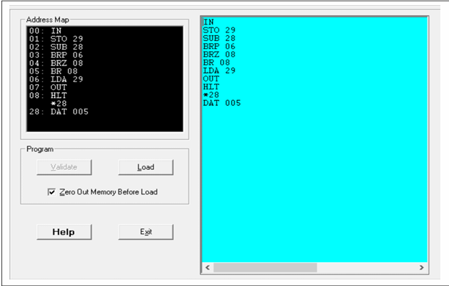

***Integer less then 5 (hardware view):***

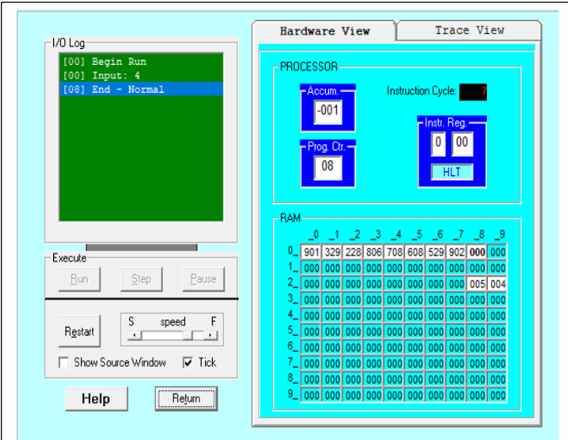

***Trace View:***

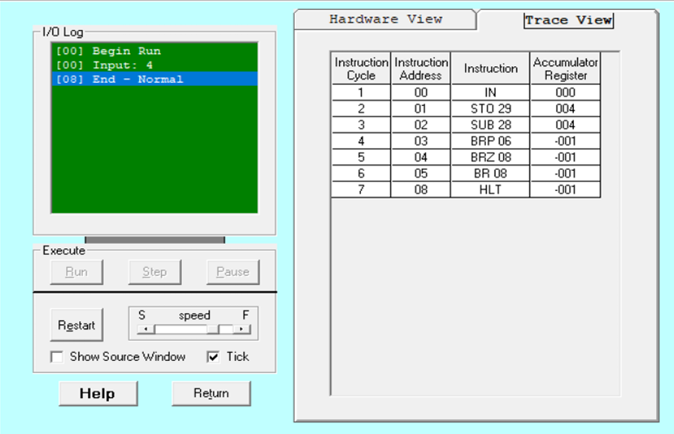

***Integer greater then 5 (hardware view):***

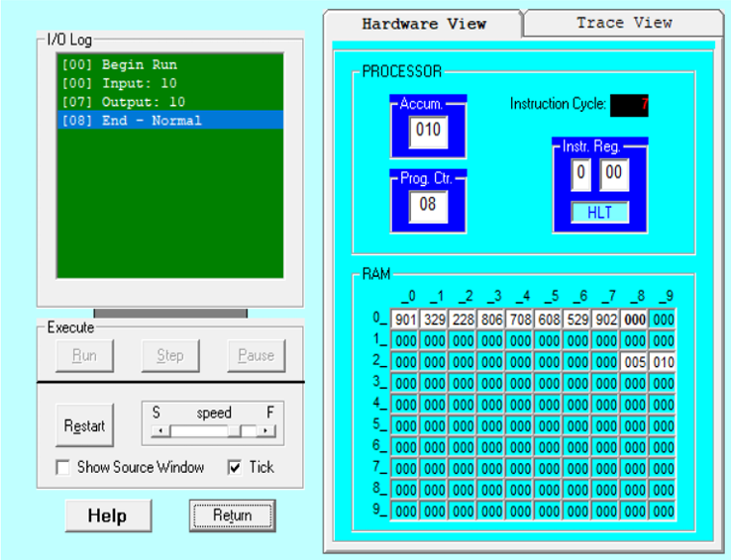

***Trace View:***

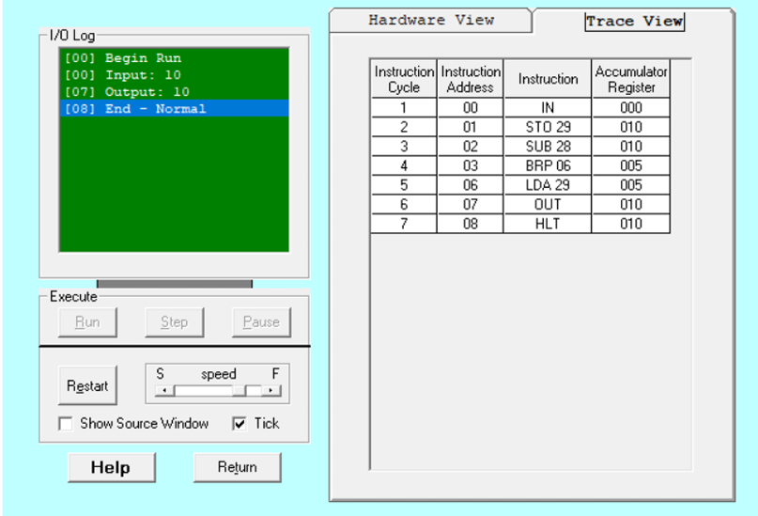

1. *Take two integers as input and subtract them.*

*If the result is positive, save and display it at the memory location of your roll number.*

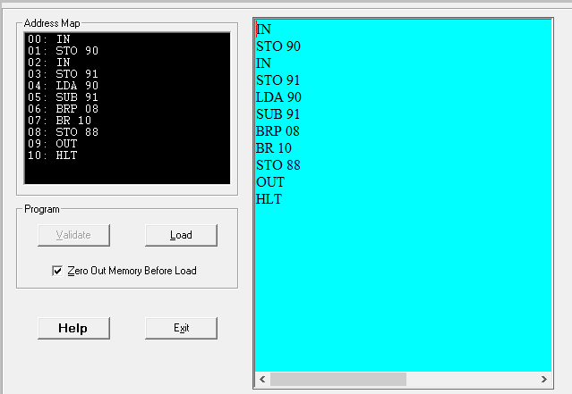

***Hardware View:***

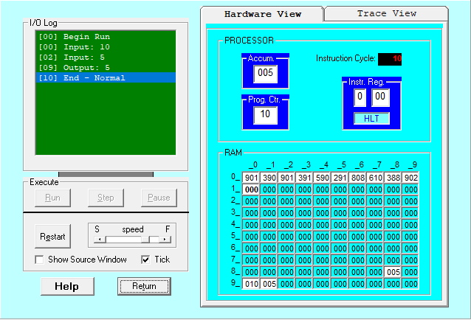

***Trace View:***

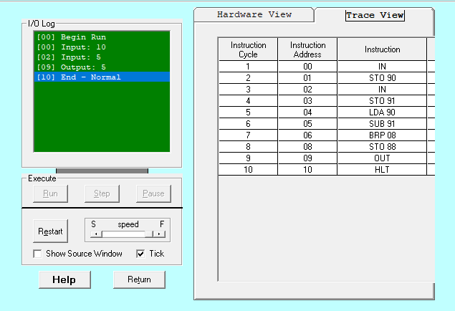

1. *Take two integers as input and print the smaller number.*

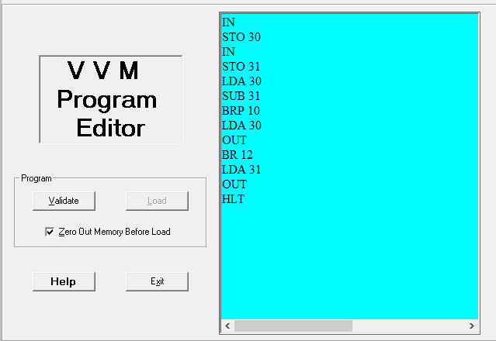

***Hardware View:***

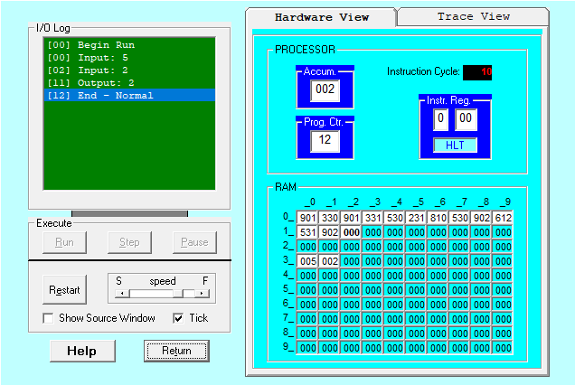

***Trace View:***

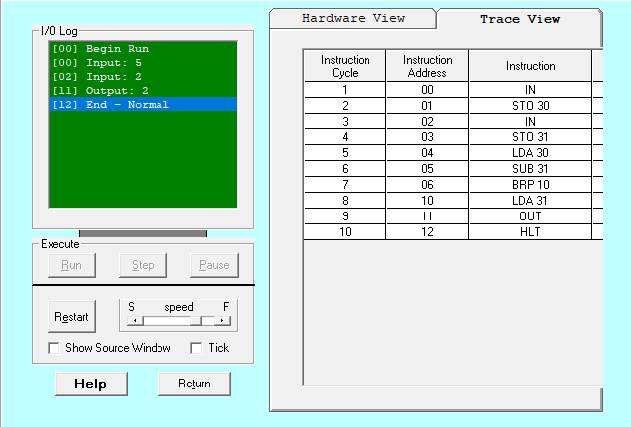

1. *Take three integer numbers as input like x1,x2,x3. Then solve: x1+x2-x3 . if the result is 0,save and print the result at the memory location 50..*

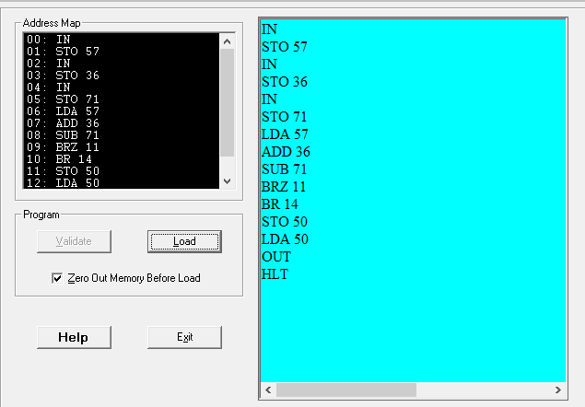

***Hardware View:***

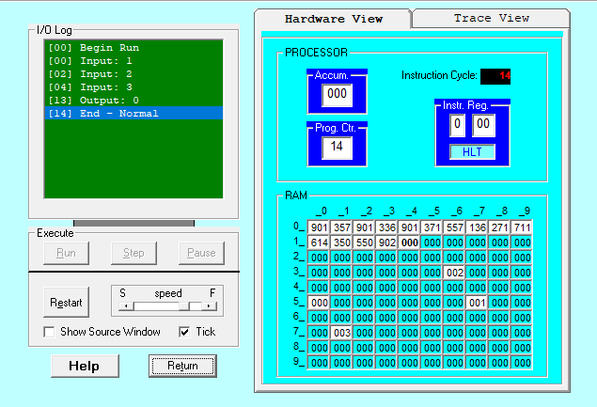

***Trace View:***

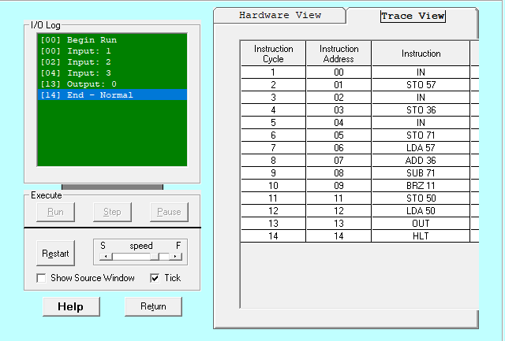

1. *Write a VVM program which take integer input and display table of that integer*

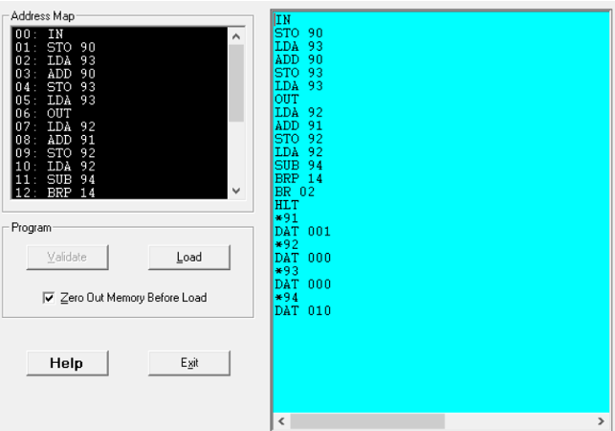

***Hardware View:***

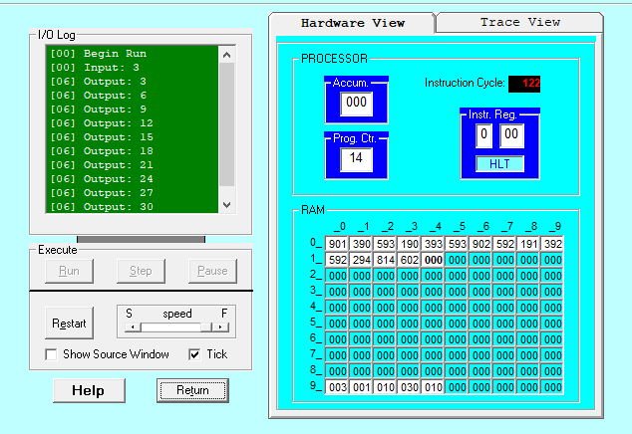

***Trace View:***

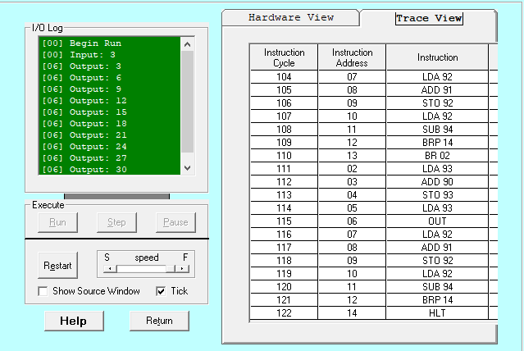

1. *Design simple loo using BRZ instruction in VVM*

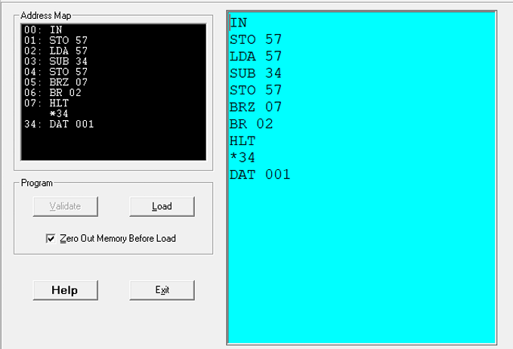

***Hardware View:***



***Trace View:***



1. *Take any integer from user. If it’s positive , print the integer . otherwise, program should be closed. Repeat the task . the no.of times of the last digit of ur rollno.*

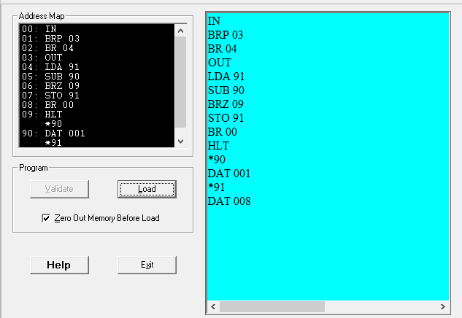

***Hardware View:***

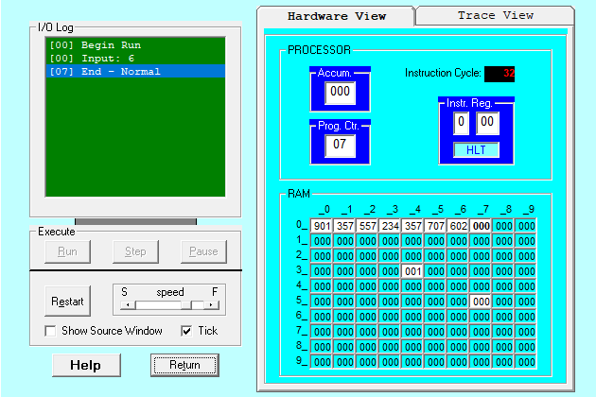

***Trace View:***

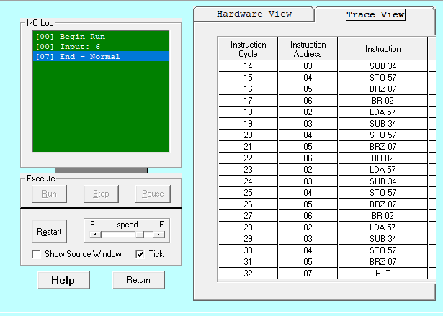

1. *Take square of any integer in range(1-20)*

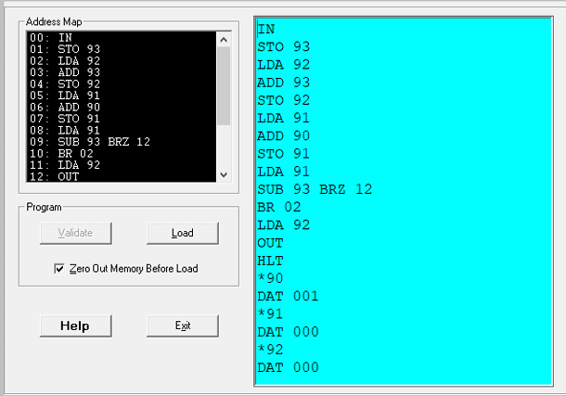

***Hardware View:***

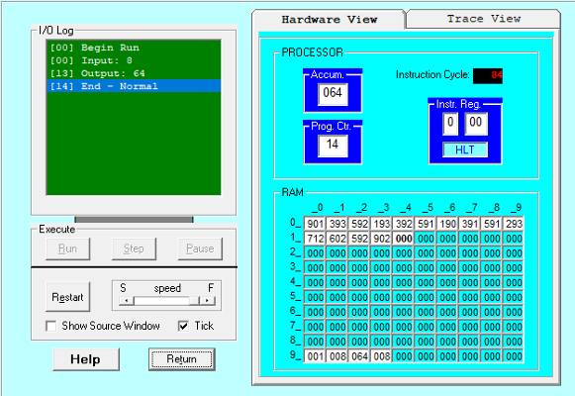

***Trace View:***

